Name: Class: Mark:

1. One characteristic of robots is that they have electrical components.
(a) Name two other characteristics of robots. [2]

(b) Identify two electrical components that a robot is likely to contain. [2]

2. One area where robots are used is in doing domestic activities and chores.
(a) Give two other areas where robots are currently used. [2]

(b) The below images show a manual batter-operated lawn mower and a robotic lawnmower.
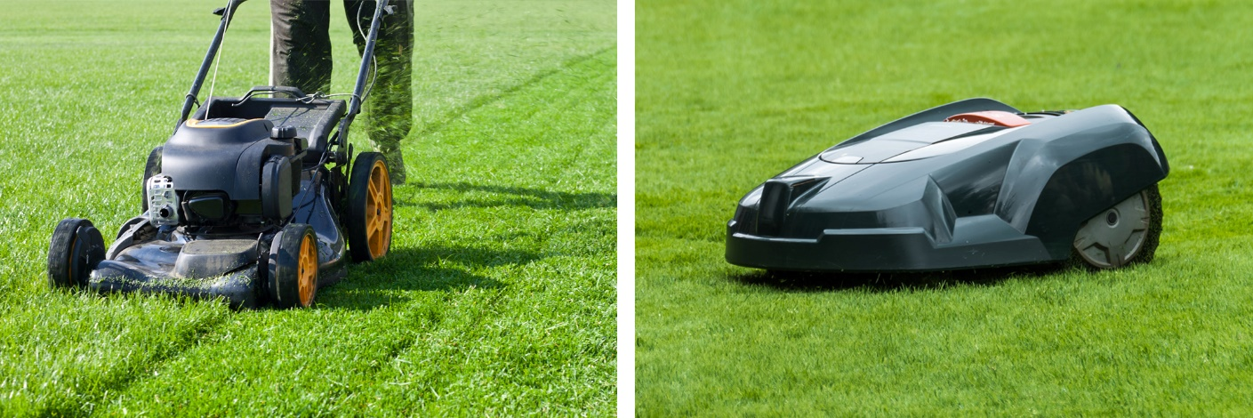
Compare a manual battery-operated lawn mower with a robotic lawnmower
by giving two similarities and two differences. [4]

(c) Give two advantages and two disadvantages of using a robotic lawnmower. [4]
Advantage 1:

Advantage 2:

Disadvantage 1:

Disadvantage 2:

[Total 14 marks]

